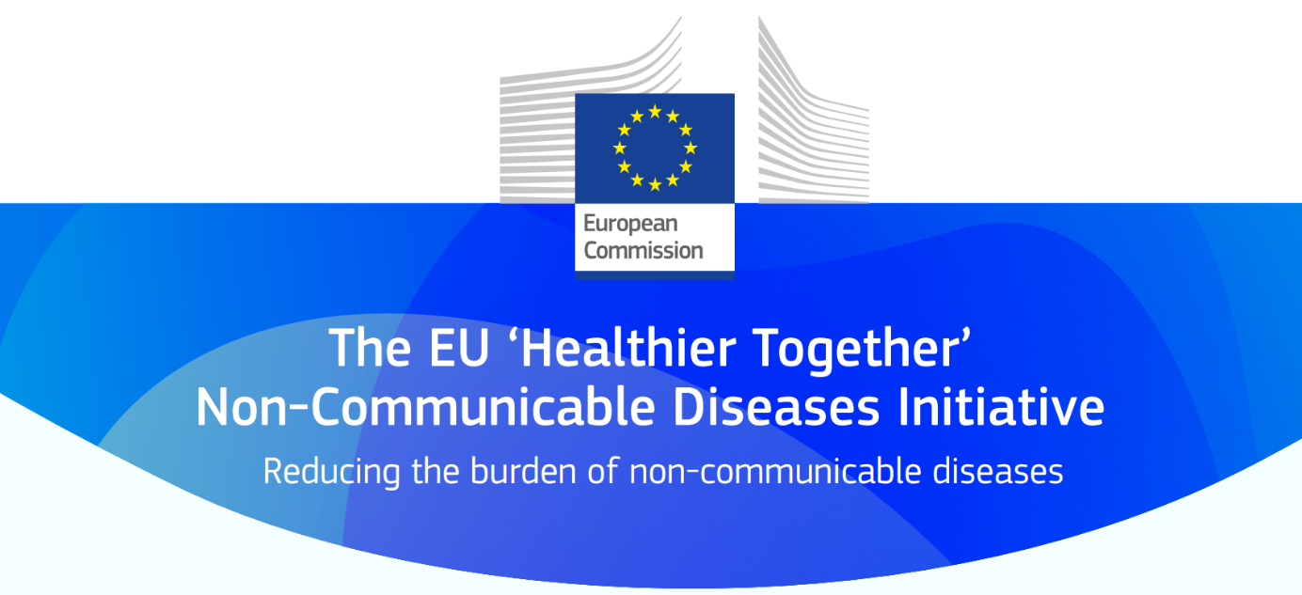

Background
Provide the rationale and background for your proposed action including challenges and enablers.

Text (max 200 words)

Concrete action  - Idea:  - What are the objectives and the scope of the action? | How will this action support the prevention of non-communicable diseases in the EU?
Text (max 50 words)

- EU added value and impact:

- What is the EU added value and impact of the action?
Text (max 200 words)

challenges and enablers  - Which issues will your action address on health promotion and prevention of non-communicable diseases in particular related to health determinants, or socio-economic, environmental, commercial determinants of health? | How will it target specific challenges, and are there any enablers that can take your action forward?
Text (max 150 words)
Implementation plan  - Provide your views on how your organisation can be involved and help in taking this idea forward. | What can your organisation do to put this idea in place?
Text (max 200 words)

